22.May.2023
To,
Drug Controller General of India
Directorate General of Health and Family Welfare,
Government of India,
FDA Bhawan, ITO,
Kotla Road, New Delhi-110002

Sub: Detailed Description of How the Raw Material Will Be Procured.

Process Flow Diagram for Purchasing Process

- Purpose: The purpose of this flow diagram is to detail the activity flow of Purchasing process
- Scope: The process flow diagram covers the purchasing of raw materials, maintenance materials, instruments, laboratory materials, and other miscellaneous items
- Approving Authority for the Process Flow Diagram: Factory Manager.
- Process Responsibility: This procedure is implemented by the Purchase Department.
- Cross- referred Process Flow Diagrams and Procedures:
- Relevant SOP
- Documents and records:
- PUR/FMT/01 – Material Indent
- PUR/FMT/02 – Purchase Register
- PUR/FMT/03 – Purchase Order
- Approved list of Vendor
- Abbreviations:
- PO – Purchase

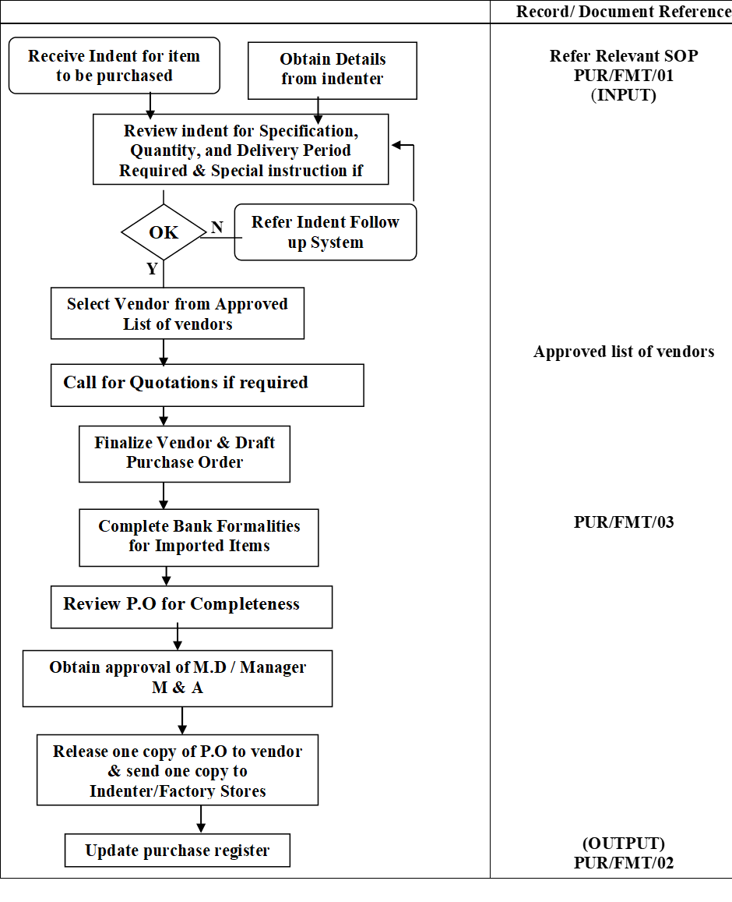
Thanking you

Yours truly,
{manufacturerName}

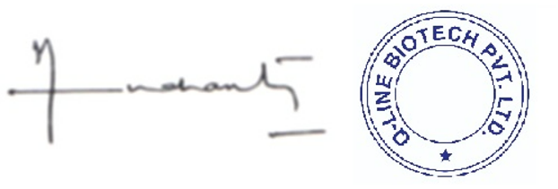
{directorName}
Director

